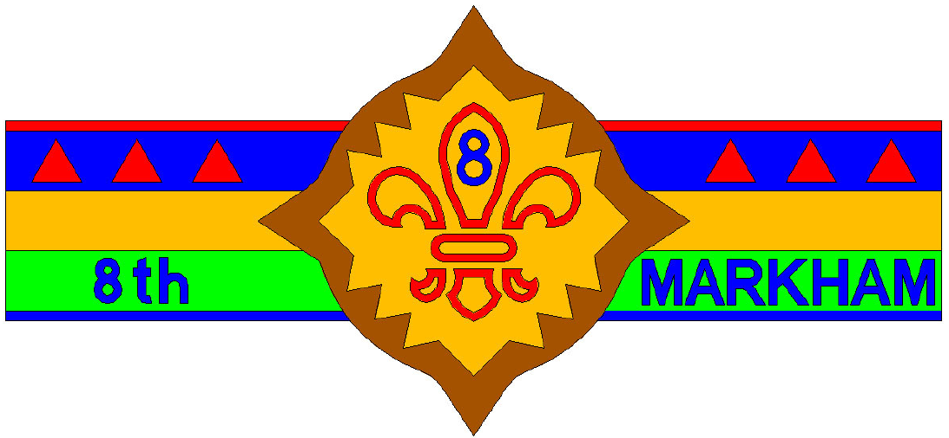

8th Markham, Scouts Canada

(2017 – 2018)

**Scuba Diving Lesson**

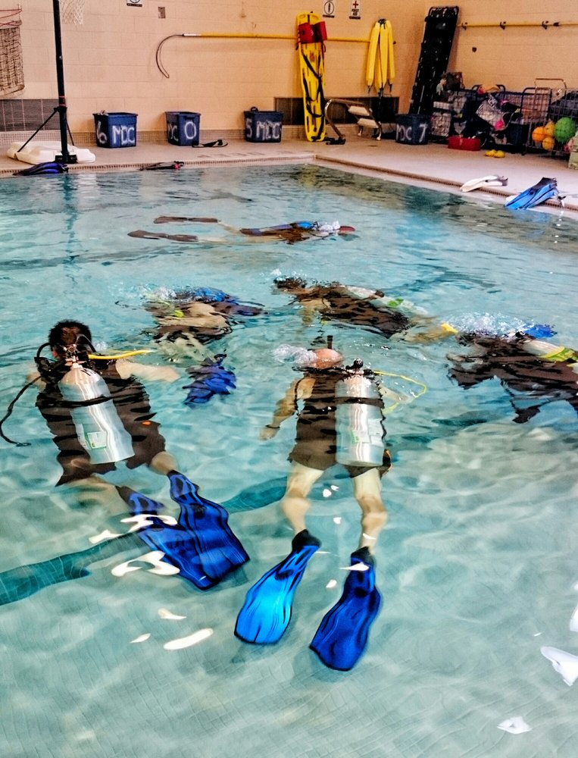

Dear Parents / Guardian,

This is to inform you that the Scouts and Venturers will have an opportunity to join this Scuba Diving Lesson date mentioned below. The youth will be offered a brief academic session and a supervised pool dive to practice key skills by highly trained PADI (Professional Association of Diving Instructors) Instructors from My Diving Center (http://mdcscuba.ca). The youth may learn up to level 5 of OAS Aquatic Skills after the completion of this lesson.

**Please Note:**

1. For safety purpose, parents / guardians of the participating scout must present at all time with the youth during the course of the lesson and pool practice. If parents/guardians must leave during the event, you must remove your youth from the event at the same time. **There is no exception to the rule.**
2. Please bring your own swimming suits, indoor/deck shoes, towel, etc.
3. Please bring your drinking water to be hydrated.
4. The **time** and **location** are still pending. We need the final count to confirm booking.

## Date: Saturday, March 17, 2018 Time: 1:00 pm – 5:00 pm

## Location: Downsview Secondary School , 7 Hawksdale Rd, North York, ON

## (to be or

## confirmed) Markham YMCA, 101 YMCA Blvd, Unionville, ON

### Cost: $30/person

---------------------------------------------------------- Cut Here and Return ----------------------------------------------------------

**Event:**  Scuba Diving

**Please return by Thursday, February 8, 2018**

I do/do not (*cross out one*) permit _________________________ to join the Scuba Diving lesson on Saturday, March 17, 2018. To comply with the requirement, I will present with my youth at all time during the entire lesson. If I must leave during the event, I will remove my child from the event at the same time.

Signature: ______________________________ Date: ___________________________

Contact Number: _________________________